WHO MADE THE NACHOS?

This critical incident was prepared by the authors and is intended to be used as a basis for class discussion. The views presented here are those of the authors based on their professional judgment and do not necessarily reflect the views of the Society for Case Research. The names of individuals, the firm, its location and relevant media outlets have been disguised to preserve anonymity. Copyright © 2014 by the Society for Case Research and the authors. No part of this work may be reproduced or used in any form or by any means without the written permission of the Society for Case Research.

Was a tweet of a disgusting employee stunt featured on the 11:00 news going to turn Taco Grande Manager Melissa Black’s world upside down and irreparably damage her career, or would it provide an opportunity to move up the corporate ladder? What damage control could she do and what was the best way to deal with the perpetrator without violating his right to privacy or getting Taco Grande into a legal mess? Before this incident everything had seemed to be going better than expected for Melissa.

Four local Taco Grande Mexican restaurants were recently nominated for the Readers’ Choice Best Restaurant Award. This recognition came as no surprise to Melissa, General Manager of the Albany Road store, as she closely adhered to the chain’s philosophy “Customer service is your number one job! Do whatever is necessary to exceed the needs of the customer!” Melissa was pleased that her store had been nominated for this award and the role she had played in the recruiting and training process to make this happen.

On the surface, it appeared that everything was going very well. However, the day-to-day issues of supervising employees in a high turnover industry soon brought her back to reality. The 10 p.m. phone call Melissa received on Wednesday and the text message that buzzed and flashed on the screen of her cell phone shortly thereafter were about to change her life. Both messages alerted her to a social media post and a news story that was about to run on an incident at her restaurant.

Christopher Roth, an employee at the Taco Grande restaurant at the Albany Road location, “tweeted” a picture showing him allegedly urinating on Taco Grande nachos inside the restaurant. He bragged about urinating on the food. To make the situation even worse, one of the area news channels brought the Twitter pictures to the attention of the public on the 11 p.m. news.

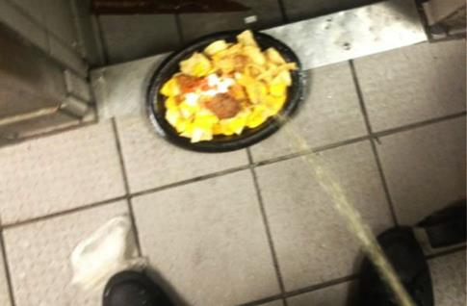

Source:WANE.com, “Employee Suspended after ‘Urine in Nachos’ Prank. (August 2, 2012), http://wane.com/news/crime/employee-suspended-after-urine-in-nachos-prank/

Nothing in Melissa’s training or experiences had prepared her for this event. In addition, there were no company policies to give her any guidance on this situation. She knew that she had to act quickly and decisively. There would be corporate, employee, media, health department and customer questions waiting for her when she arrived at work. What should she do now, and how could she prepare to face the unknown in just a few short hours?